**PEnY6/111KA** CP6HJA

# PEnY6Jl114Kl1 l"EOAETCKl1 3ABOA

CJ1y,t<6a 38 K8Tacrap HenOKpeTH00'\18n8,QH4HH XaH CseTOcaacKa 6p.1

# 6poj: 953·1/2022-54

**KOnli1JA KATACTAPCKOr MAHA**

KaTacrapc•a napt1e11a 6poj: 2046, 2040, 2037, 2031, 2082, 2017,

2015, 2039, 2038, 2030 H Apyre.

KO: npeKOAOn11e Pa3Mepa wraMne: 1:1500

*1992*

*1996 199* ***2046***

I *1993 --*

**1-----** --!

*19 .*

/laTyM H apeMe S3ll<lBatba:

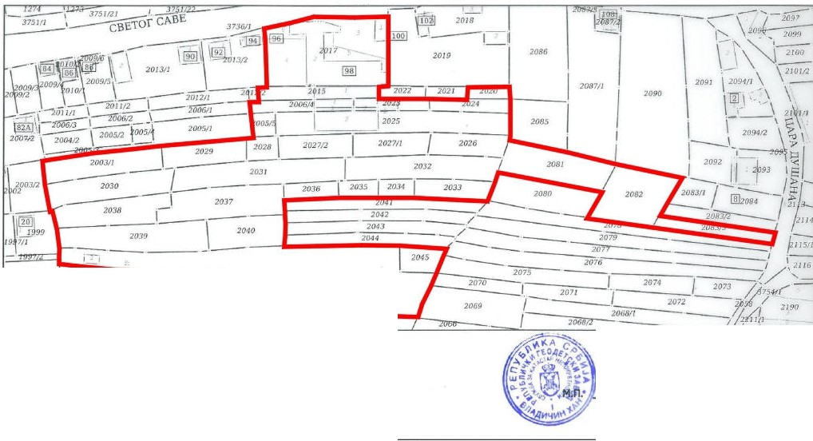

27.12.2022 rOAWHey08:01

npocropHHo6yxsar TinaHa

**OellawlleHo run;e:**

**TCMlrOll'!CUt"'"'°8...,_ = o,_...("(ao_**